Lagged cross-correlation: USDJPY and USDCHF
Method 12 / daily log returns / K_max=10 / Alpari D1 full available history

Study setup
Logical pair: USDJPY , USDCHF
Broker symbols: USDJPY_i , USDCHF_i
Snapshot: 2026-11-03_majors_alpari_D1
Timeframe: D1
Matched return window: 1999-01-05 to 2026-11-02 (UTC bar dates)
Matched return count n: 7185
Dropped unfinished last bar dated 2026-11-03 UTC after a tick-volume check against the prior complete day.
Lag definition: rho_X->Y(k) = Corr(x_t, y_{t+k}) on matched D1 bars
K_max = 10; headline lag k = 1 (both directions)
Complete matched rows (Excel): USDJPY-USDCHF_Lagged_D1.xlsx
Complete matched rows (HTML table): USDJPY-USDCHF_Lagged_D1_data.html

Method carried forward
Lagged cross-correlation measures Pearson correlation between matched daily log returns of close, ln(close_t / close_t-1), after shifting one series forward by k bars on the matched panel. Quotes are not inverted. rho_{X->Y}(k) = Corr(x_t, y_{t+k}) with n_k = n - k. K_max = 10 is fixed before estimation. The headline is the pre-specified lag k = 1 in both directions. k = 0 is the same-bar side check. The lag inside 1..10 with the largest absolute rho is stored as a descriptive column only; it is not a selected result. This is a linear screen, not proof of forecast edge, economic cause, or a trading signal.

Results (headline k=1)
rho_USDJPY->USDCHF(1): -0.030792 (n=7184)
95% Fisher interval USDJPY->USDCHF: [-0.053878, -0.007672]
rho_USDCHF->USDJPY(1): -0.012692 (n=7184)
95% Fisher interval USDCHF->USDJPY: [-0.035806, 0.010436]
Same-bar rho(k=0): 0.399461
Largest |rho| among k=1..10 (descriptive only, not selected): USDJPY->USDCHF k=1 rho=-0.030792; USDCHF->USDJPY k=8 rho=0.022396

CCF table
k | rho_USDJPY_to_USDCHF | n_USDJPY_to_USDCHF | rho_USDCHF_to_USDJPY | n_USDCHF_to_USDJPY
0 | 0.39946087 | 7185 | 0.39946087 | 7185
1 | -0.03079173 | 7184 | -0.01269191 | 7184
2 | 0.00164657 | 7183 | -0.00264857 | 7183
3 | 0.01363638 | 7182 | -0.01133123 | 7182
4 | 0.02390685 | 7181 | -0.01808982 | 7181
5 | -0.00525167 | 7180 | 0.01326114 | 7180
6 | -0.01176653 | 7179 | -0.0103377 | 7179
7 | 0.0017216 | 7178 | -0.00160493 | 7178
8 | 0.01940758 | 7177 | 0.02239601 | 7177
9 | -0.00554128 | 7176 | 0.0054476 | 7176
10 | 0.01118965 | 7175 | 0.017386 | 7175

Conclusion
At the pre-specified lag k=1 for USDJPY and USDCHF, rho_{USDJPY->USDCHF}(1) = -0.0308 (n=7184) and rho_{USDCHF->USDJPY}(1) = -0.0127 (n=7184). Same-bar rho(k=0) = 0.3995. Largest |rho| among k=1..10 is descriptive only: USDJPY->USDCHF at k=1 (-0.0308); USDCHF->USDJPY at k=8 (0.0224). This is a linear screen, not forecast proof or a trading signal.

Charts
Daily closes

Daily log returns

CCF both directions k=0..10
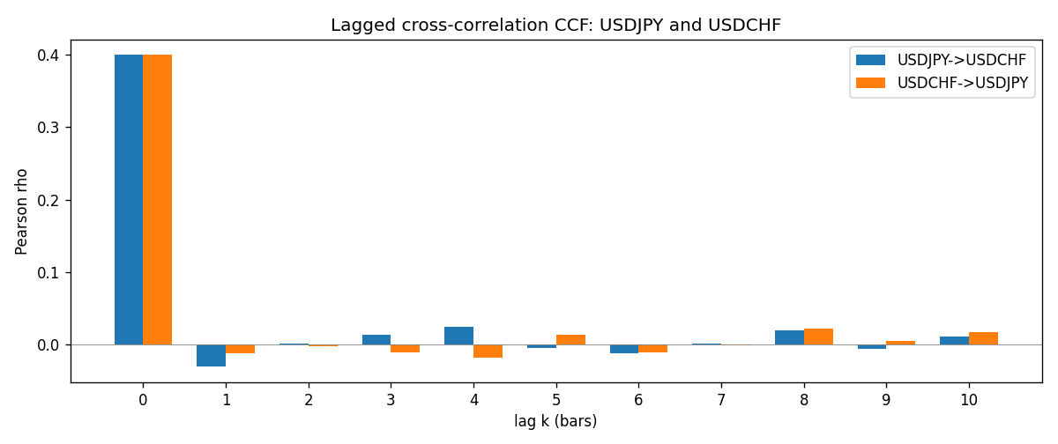

Data report
Every matched row is stored in the sibling Excel workbook named USDJPY-USDCHF_Lagged_D1.xlsx (sheet matched_rows). The CCF sheet holds rho(k) for k=0..10. Embedding all rows as a Word table is impractical; the Word file holds column summaries and the first and last 15 rows.
Columns: time, USDJPY_open, USDCHF_open, USDJPY_high, USDCHF_high, USDJPY_low, USDCHF_low, USDJPY_close, USDCHF_close, USDJPY_tick_volume, USDCHF_tick_volume, USDJPY_spread, USDCHF_spread, USDJPY_real_volume, USDCHF_real_volume, USDJPY_log_return, USDCHF_log_return
Column summaries (matched calculation rows)
column | count | mean | std | min | 25% | 50% | 75% | max
USDJPY_open | 7185 | 113.80726 | 19.2236 | 75.693 | 104.38 | 110.984 | 120.69 | 163.824
USDCHF_open | 7185 | 1.0974395 | 0.25223318 | 0.72022 | 0.92053 | 0.98988 | 1.2375 | 1.8219
USDJPY_high | 7185 | 114.30433 | 19.285132 | 76.001 | 104.865 | 111.442 | 121.257 | 163.978
USDCHF_high | 7185 | 1.1027315 | 0.25397793 | 0.73305 | 0.92474 | 0.99353 | 1.2422 | 1.8313
USDJPY_low | 7185 | 113.28455 | 19.151449 | 75.402 | 103.87 | 110.53 | 120.17 | 163.628
USDCHF_low | 7185 | 1.0923205 | 0.25064913 | 0.08565 | 0.91719 | 0.98622 | 1.2315 | 1.8121
USDJPY_close | 7185 | 113.82023 | 19.238853 | 75.811 | 104.38 | 111.025 | 120.68 | 163.851
USDCHF_close | 7185 | 1.0974333 | 0.25214008 | 0.72025 | 0.92079 | 0.98995 | 1.2376 | 1.8217
USDJPY_tick_volume | 7185 | 106345.59 | 179437.4 | 149 | 9958 | 53202 | 92889 | 1803508
USDCHF_tick_volume | 7185 | 74334.331 | 113494.7 | 18 | 12809 | 40241 | 70443 | 858589
USDJPY_spread | 7185 | 20.263883 | 17.612444 | 0 | 6 | 11 | 30 | 50
USDCHF_spread | 7185 | 26.03215 | 24.694045 | 0 | 5 | 16 | 50 | 100
USDJPY_real_volume | 7185 | 3.4781051e+10 | 1.6093614e+11 | 0 | 0 | 0 | 0 | 3.8834203e+12
USDCHF_real_volume | 7185 | 2.3294091e+10 | 8.9133595e+10 | 0 | 0 | 0 | 0 | 1.9331921e+12
USDJPY_log_return | 7185 | 4.82e-05 | 0.00620617 | -0.03908203 | -0.00320044 | 0.00011473 | 0.00340924 | 0.05184024
USDCHF_log_return | 7185 | -6.962e-05 | 0.0065941 | -0.19545699 | -0.0033516 | 8.06e-05 | 0.00332472 | 0.09051364
First 15 matched rows (selected columns)
time | USDJPY_close | USDCHF_close | USDJPY_log_return | USDCHF_log_return
1999-01-05 | 111.92 | 1.3724 | -0.00017868311 | 0.0039424743
1999-01-06 | 112.77 | 1.3912 | 0.0075660159 | 0.013605652
1999-01-07 | 111.33 | 1.3782 | -0.012851583 | -0.0093883841
1999-01-08 | 110.8 | 1.3935 | -0.0047719894 | 0.011040268
1999-01-11 | 109.02 | 1.4009 | -0.016195423 | 0.0052963193
1999-01-12 | 112.6 | 1.3872 | 0.032310364 | -0.0098275602
1999-01-13 | 113.52 | 1.3621 | 0.0081373171 | -0.018259701
1999-01-14 | 113.52 | 1.3588 | 0 | -0.0024256692
1999-01-15 | 114.15 | 1.3834 | 0.0055343401 | 0.01794228
1999-01-18 | 114.16 | 1.379 | 8.7600193e-05 | -0.0031856384
1999-01-19 | 113.52 | 1.3789 | -0.0056219403 | -7.2518946e-05
1999-01-20 | 112.91 | 1.3889 | -0.0053879917 | 0.0072259871
1999-01-21 | 113.87 | 1.3836 | 0.0084664056 | -0.0038232689
1999-01-22 | 114.56 | 1.3834 | 0.0060412564 | -0.0001445609
1999-01-25 | 113.72 | 1.3868 | -0.0073594164 | 0.0024546976
Last 15 matched rows (selected columns)
time | USDJPY_close | USDCHF_close | USDJPY_log_return | USDCHF_log_return
2026-10-13 | 158.305 | 0.83244 | -0.0018932826 | -0.0024955621
2026-10-14 | 158.317 | 0.83489 | 7.5800166e-05 | 0.0029388325
2026-10-15 | 158.024 | 0.82676 | -0.0018524319 | -0.0097855323
2026-10-16 | 157.964 | 0.82377 | -0.00037976126 | -0.0036230826
2026-10-19 | 158.517 | 0.82677 | 0.0034946841 | 0.0036351779
2026-10-20 | 158.16 | 0.8246 | -0.0022546642 | -0.0026281224
2026-10-21 | 158.108 | 0.82427 | -0.00032883504 | -0.00040027413
2026-10-22 | 156.755 | 0.82032 | -0.0085942669 | -0.0048036381
2026-10-23 | 156.81 | 0.82497 | 0.00035080446 | 0.005652514
2026-10-26 | 157.458 | 0.82649 | 0.0041238746 | 0.0018407959
2026-10-27 | 157.894 | 0.82865 | 0.0027651658 | 0.0026100526
2026-10-28 | 157.743 | 0.82781 | -0.00095679538 | -0.0010142111
2026-10-29 | 157.683 | 0.82379 | -0.00038043789 | -0.0048680164
2026-10-30 | 157.516 | 0.82438 | -0.0010596481 | 0.00071594559
2026-11-02 | 157.933 | 0.81851 | 0.0026438521 | -0.0071459744

